**03. AWS EKS and X-Ray Network Design**

--- In this lecture, we are going to understand about, how we are going to deploy our applications in

relation with aws x-ray on EKS cluster.

--- everything we are going to look into it from a network perspective, how it is going to look like.

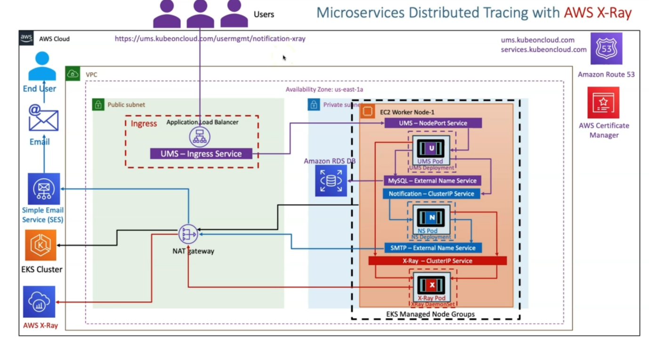

--- in aws cloud. when we create a EKS cluster, it is going to create a equilent VPC, public subnets, private subnet’s and nat gateway.

--- whenever you created a EKS managed nodegroup, it also creates worker node and whatever the applications deployed on this worker node. this worker node related Kubelet and all those stuffs will communicate to the EKS cluster using nat gateway because these worker nodes are created in the private subnet.

--- whenever you deploy an X-ray as a deamonset. it is going to create x-ray pod per worker node and then it is going to expose that respective X-ray pod related application using X-ray clusterip service.

--- we deploy our user management application and then notification application. it will have its own stuff; UMS will have its own nodeport service and then mysql external name service.

--- notification service will have its notification clusterip service and its SMTP external name service to send email via simple email service.

--- the next thing is so that you will also create your ingress service, which is nothing but your application load balancer in the public subnet.

--- whenever you create the ingress service, it will reference this SSL certificate from the certificate

Manager and also you are going to register your DNS name inside ROUTE53 using external DNS.

--- for X-RAY related thing. in this ums and in notification, I have written the code with x ray sdk to enable the x-raytracing for only this respective micro service (<https://ums.kubeoncloud.com/usermgmt/notification-xray>)

--- you are calling a notification x-ray micro service from user management micro service. So, what happens at that time?

--- the request comes UMS Ingress service and from there, it will go to the UMS NodePort Service and then request will go to UMS pod and from there it will go to the notification clusterip service because you are calling the notification x ray service here and from that request will come back to the notification pod.

**AWS X-RAY – service Map**

